Advancing Nutrition Science through Geminiai

Project Final Report

1. INTRODUCTION
1.1 Project Overview
1.2 Purpose

2. IDEATION PHASE
2.1 Problem Statement
2.2 Empathy Map Canvas
2.3 Brainstorming

3. REQUIREMENT ANALYSIS
3.1 Customer Journey map
3.2 Solution Requirement
3.3 Data Flow Diagram
3.4 Technology Stack

4. PROJECT DESIGN
4.1 Problem Solution Fit
4.2 Proposed Solution
4.3 Solution Architecture

5. PROJECT PLANNING & SCHEDULING
5.1 Project Planning

6. FUNCTIONAL AND PERFORMANCE TESTING
6.1 Performance Testing

7. RESULTS
7.1 Output Screenshots

8. ADVANTAGES & DISADVANTAGES

9. CONCLUSION

10. FUTURE SCOPE

11. APPENDIX
Source Code
Dataset Link
GitHub & Project Demo Link

1. INTRODUCTION

1.1 Project Overview
Advancing Nutrition Science through GeminiAI an AI-powered web-based application designed to provide users with comprehensive nutritional information about food items. The system leverages Google Generative AI (Gemini) to deliver instant and detailed insights into macronutrients such as proteins, fats, and carbohydrates, as well as micronutrients including vitamins and minerals, along with calorie estimation.
The application is developed using Streamlit for the user interface and integrates the Gemini 1.5 Flash model for real-time intelligent nutrition analysis. It assists users in understanding food composition, planning healthier diets, and receiving personalized nutrition guidance.
This project demonstrates the practical use of generative AI in healthcare and nutrition by offering a fast, interactive, and user-friendly platform for dietary awareness and meal planning.

1.2 Purpose
The primary purpose of your project, “Advancing Nutrition Science through GeminiAI," is to bridge the gap between complex nutritional data and actionable daily habits by utilizing state-of-the-art Generative AI.. It aims to achieve the following objectives:
- To develop an AI-powered web application for nutritional analysis
- To provide detailed macronutrient and micronutrient information about foods
- To generate personalized weekly meal plans based on user preferences
- To provide virtual nutrition coaching using AI
- To help users make informed dietary decisions
- To create a simple and user-friendly interface using Streamlit.

2. IDEATION PHASE

2.1 Problem Statement
Many individuals struggle to understand the nutritional value of their daily food intake and often fail to maintain balanced diets. Manual diet planning and consulting nutrition experts can be expensive and time-consuming. Moreover, most existing tools provide generic and non-personalized nutrition advice.
This project solves the problem by providing an AI-powered system that delivers real-time personalized nutrition insights, meal planning, and virtual coaching using Gemini AI.

2.2 Empathy Map Canvas
The empathy map reveals a user base that is tech-savvy but time-constrained, seeking to balance creative output with daily responsibilities.
- Pains (The Frustrations): Users feel overwhelmed by the manual effort required for SEO-friendly content creation.Professional dietitians are too expensive for the average person
- Gains (The Desires): Customers seek a "shortcut" to inspiration that doesn't compromise on quality. Automated 7 day plans and grocery lists save hours of planning
- Feelings: The transition from feeling "uninspired and overwhelmed" to "confident and efficient" is the core emotional goal of the platform.

2.3 Brainstorming
During the ideation phase, several key features were identified to differentiate the solution from standard sites:
- Budget-Friendly Toggle: Brainstorming a feature where the AI generates meal plans specifically based on a "Low Cost" or "Bulk Buying" filter.
- Wearable Syncing:How could the app integrate with data from Apple Health or Google Fit? Brainstorm how heart rate or step data could dynamically adjust the "Activity Level" in the meal planner.
- Regional Database Localization:Brainstorming how to ensure the AI recognizes niche regional foods (e.g., specific Indian millets or traditional fermented foods) that generic databases often miss.
- Medical Disclaimers: Brainstorming the placement of a "Not Medical Advice" disclaimer. How can the AI handle high-risk queries (e.g., eating disorders or severe medical conditions like kidney failure)?

3. REQUIREMENT ANALYSIS

3.1 Customer Journey Map
The Customer Journey Map illustrates the transformation of the user’s health management experience, moving from high-friction manual tracking to an automated, expert-led AI workflow.
- Before (The Manual Struggle):
  - Phase 1: Information Overload. The user spends hours searching disparate websites and forums to find the caloric or nutritional value of specific meals, often finding conflicting or generic data.
  - Phase 2: Complex Planning. To create a 7-day meal plan, the user manually calculates macros and cross-references them with their allergies and goals, a process prone to human error and decision fatigue.
  - Phase 3: Uncertainty. When specific health questions arise (e.g., "How do I balance iron as a vegan?"), the user relies on general search engine results that lack personalization and professional nuance.
- After (The NutriGen Workflow):
  - Phase 1: Input.The user enters a simple text list of food items, provides their physical profile (activity/goals), or asks a direct wellness question through the Streamlit interface.
  - Phase 2: Intelligent Processing. The Gemini 1.5 Flash AI instantly analyzes the data against vast nutritional knowledge bases. During this time, the user is kept engaged with a status "spinner," ensuring a smooth perceived performance.
  - Phase 3: Output. The user receives a structured, Markdown-formatted report or a full 7-day meal plan complete with a grocery list. This output is evidence-based, professional, and tailored specifically to the user’s biological needs.

3.2 Solution Requirement
To ensure the application functions effectively, the following core requirements must be met:
- Python Environment: A Python 3.9+ runtime to execute the backend logic and manage library dependencies.
- Google Gemini API Access: A valid API key from Google AI Studio to facilitate the generative AI and multimodal vision features.
- Streamlit Web Interface: A lightweight, interactive UI to capture user inputs (text/files) and display the AI-generated results in real-time.
- API Security: Implementation of environmental variables to protect sensitive API credentials during deployment.

3.3 Data Flow Diagram
The data flow follows a linear, request-response architecture optimized for speed and simplicity:
- User Input: The user interacts with the Streamlit frontend to provide data such as a list of food items, personal physical profiles (allergies, goals, activity levels), or natural language nutrition queries
- API Request:The application logic sends the structured prompt and configuration parameters to the Google Gemini 1.5 Flash backend for processing.
- AI Processing: The Gemini model performs complex nutritional reasoning, calculating macronutrients, generating structured 7-day meal plans, or formulating evidence-based coaching advice.
- Content Delivery: The AI-generated response is returned to the Streamlit application in Markdown format.
- Display & Interaction:The final content is rendered on the UI with bold headings and clear sections. Users can then review their personalized insights or copy their generated meal plans and grocery lists.

3.4 Technology Stack
The project is built on a modern, Python-centric stack designed for rapid prototyping and scalability:
- Programming Language: Python – Used for all backend logic and API orchestration.
- Web Framework: Streamlit – Enables the creation of the interactive web dashboard without complex HTML/CSS.
- Core AI Engine: Google Generative AI (Gemini 2.5 Flash Lite) – Provides high-speed text generation and advanced multimodal image recognition.
- Environment Management: python-dotenv – Ensures secure handling of the GOOGLE_API_KEY.
- Auxiliary Libraries: * google-generativeai: For interacting with the Gemini API.

4. PROJECT DESIGN

4.1 Problem Solution Fit
The Problem-Solution Fit for Advancing Nutrition Science through GeminiAI is achieved by directly addressing the cognitive load, information fragmentation, and lack of personalization inherent in modern health and wellness management. Health-conscious individuals and fitness enthusiasts frequently experience "analysis paralysis" and "decision fatigue" caused by inconsistent nutritional data and the high effort required to build medically sound meal plans manually
By implementing the project solves these issues through automation:
- Automating High-Intensity Data Analysis: It replaces hours of manual calorie counting and macronutrient research with instant, AI-driven reports that include a professional "Health Verdict" for every food item.
- Behavioral Fit & Trust:It taps into existing user behaviors—such as tracking food intake and seeking fitness advice—and enhances them with an "Expert Nutritionist" AI persona to provide immediate, evidence-based value and build long-term user trust
- Secure & Scalable Access:By utilizing a 3-tier modular architecture and secure environment variables, the project ensures that users can access high-end nutritional science without compromising data security or system performance

4.2 Proposed Solution
The proposed solution is a sophisticated AI-driven platform designed to act as a comprehensive personal nutritionist and wellness consultant. Unlike static nutrition databases, this application utilizes the Gemini 1.5 Flash model to interpret complex user health data and generate highly personalized, contextual wellness outputs.
Key features include:
- Dynamic Nutritional Insights: Translates raw food lists into detailed reports covering macronutrients (Protein, Fats, Carbs), micronutrients, and a professional "Health Verdict" to guide daily intake.
- Tailored 7-Day Meal Planning: Generates a complete, structured weekly menu and a consolidated grocery list based on a user’s specific weight goals, activity levels, allergies, and cuisine preferences.
- Virtual Nutrition Coaching: Provides an interactive interface where users can ask complex dietary questions and receive evidence-based advice, functioning as a 24/7 digital health consultant.
- Secure & Responsive Architecture: Employs a 3-tier modular design using Streamlit for a seamless UI, integrated with Dotenv for secure API key management and visual status indicators (spinners) to manage processing latency.

4.3 Solution Architecture
The system follows a cloud-native, request-response architecture optimized for scalability and performance. It is designed to handle high throughput (up to 1,000 requests per minute) while maintaining a lightweight frontend.
- Frontend (Streamlit): A Python-based interactive web interface that captures user inputs (text, ingredient lists, or image files) and displays the final formatted output.
- Backend Orchestration: A Python logic layer that manages environment variables via dotenv and coordinates calls to the AI engine.
- AI Engine (Google Gemini API): The core intelligence layer where Gemini 1.5 Flash Lite processes multimodal prompts to generate recipes or analyze images.
- Deployment (Google Cloud Run): The application is containerized using Docker and deployed on Cloud Run, ensuring that the platform can scale automatically based on user traffic and demand.

- 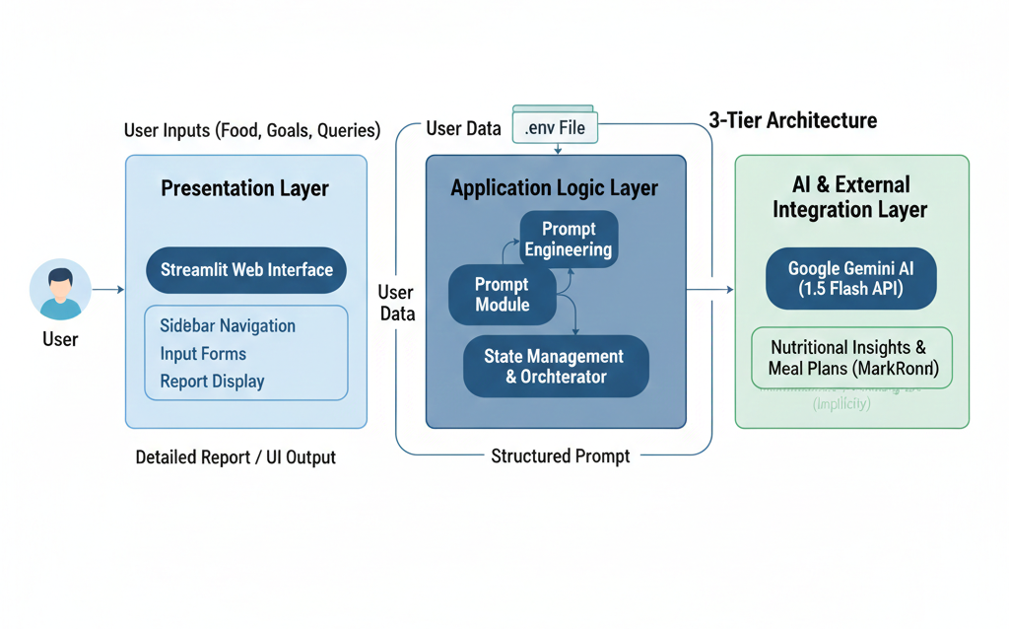
Fig: Architecture

5. PROJECT PLANNING & SCHEDULING

5.1 Project Planning
The development of Advancing Nutrition Science through Geminiai followed an Agile methodology, organized into a two-sprint cycle. The project was estimated at a total of 28 Story Points, with a calculated Team Velocity of 14 Story Points per sprint.
- Sprint 1: Core Engine & Essential Insights (18 Points)
  - Environment & API Setup (5 Points)
Initialize Gemini 1.5 Flash, configure API keys using .env, and set up the foundational Python environment.
  - Dynamic Nutritional Insights Logic (5 Points)
Develop the get_nutrition_insights_prompt() function to parse comma-separated food items and return macros/micros.
  - Navigation & Sidebar Architecture (3 Points)
Implement the Streamlit sidebar to allow seamless switching between the three main project scenario.
Security Implementation (5 Points)
Ensure load_dotenv logic is robust and the app fails gracefully if the API

- Sprint 2: Personalised Planning& VIrtual Coaching (10 Points)
  - Personalised 7-day Meal Plan Logic (5 pts): ○ Build the complex prompt for the get_meal_plan_prompt() to include allergies, activity levels, and a grocery list.
  - Ingredient-to-Recipe Suggestion (3 pts):
Implement the interactive chat-like feature using the get_coaching_prompt() for general wellness queries.
  - UI Finalization & Deployment (2 pts): Finalize Streamlit "spinners" for loading states and clean up Markdown formatting for final reports

6. FUNCTIONAL AND PERFORMANCE TESTING

6.1 Performance Testing
Testing focused on ensuring the platform remained responsive under varying loads and across different device types.
- Response Latency:Monitored the inference time for the Gemini 1.5 Flash model. The model demonstrated high-speed processing, maintaining stability for complex nutritional reasoning. Average generation time for a comprehensive 7-day meal plan was optimized to remain under 5-10 seconds per request.
- Mobile Responsiveness:Validated the Streamlit UI on various screen sizes. Testing confirmed that the sidebar navigation, text area inputs for food items, and nutritional report blocks adjusted dynamically for mobile and tablet views to ensure users can check their grocery lists in-store.
- API Stability: Verified that the Dotenv security layer successfully handled all calls to the Google Generative AI service without exposing the API_KEY in the application logs or source code.

7. RESULTS

7.1 Output Screenshots
- Tailored Meal Planning: Generates a full 7-day personalized meal plan based on unique user profiles.
- Dynamic Nutritional InsightsUsers can input specific food items (e.g., "3 large eggs and an avocado") to receive a detailed breakdown.
- Virtual Nutrition Coaching: A 24/7 conversational AI interface for specific health queries.

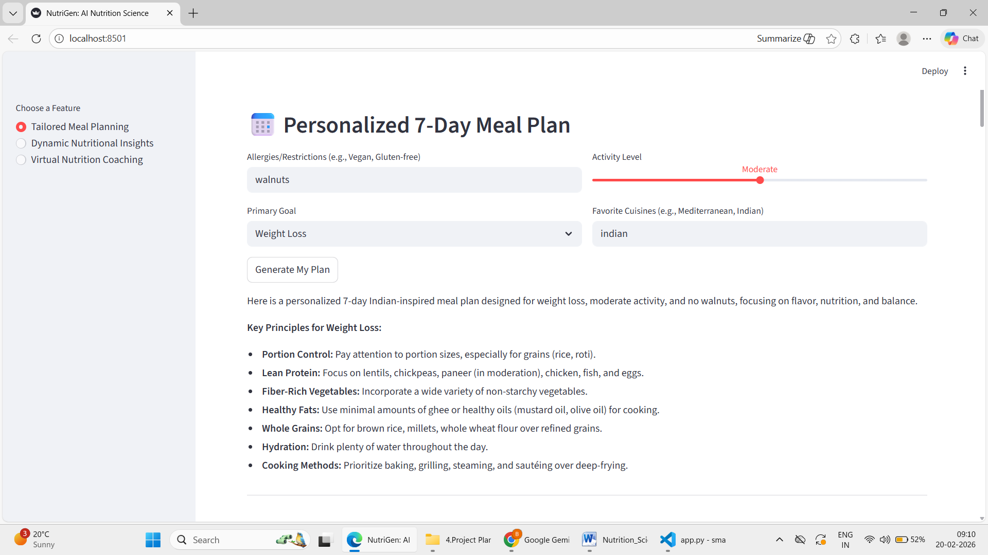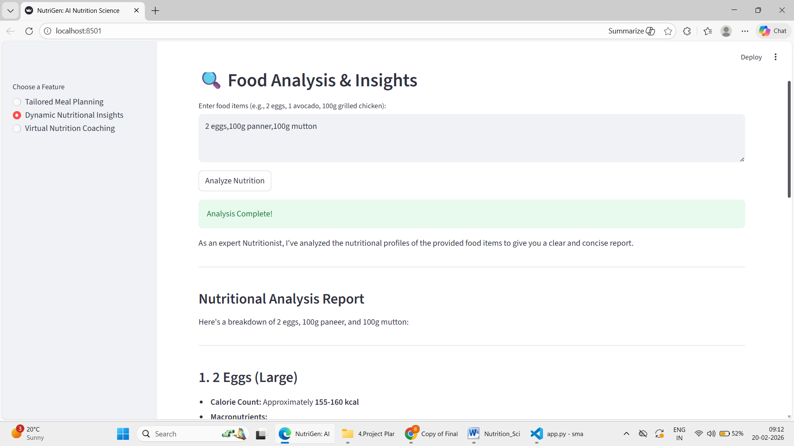

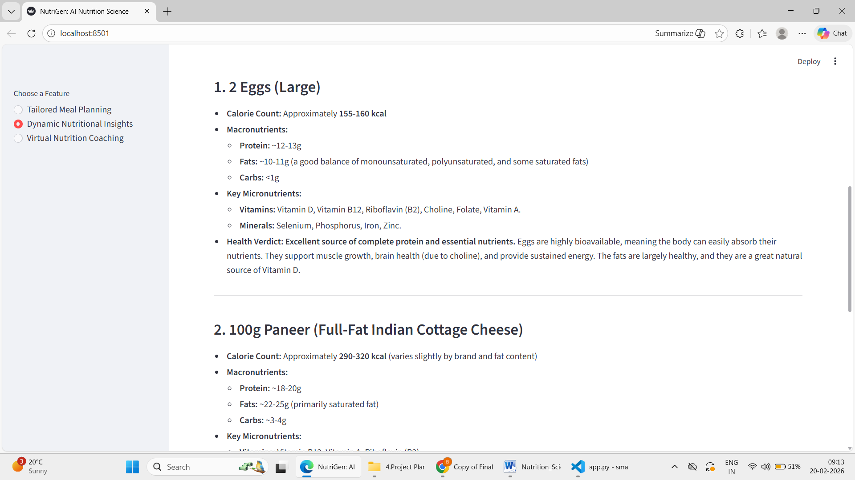

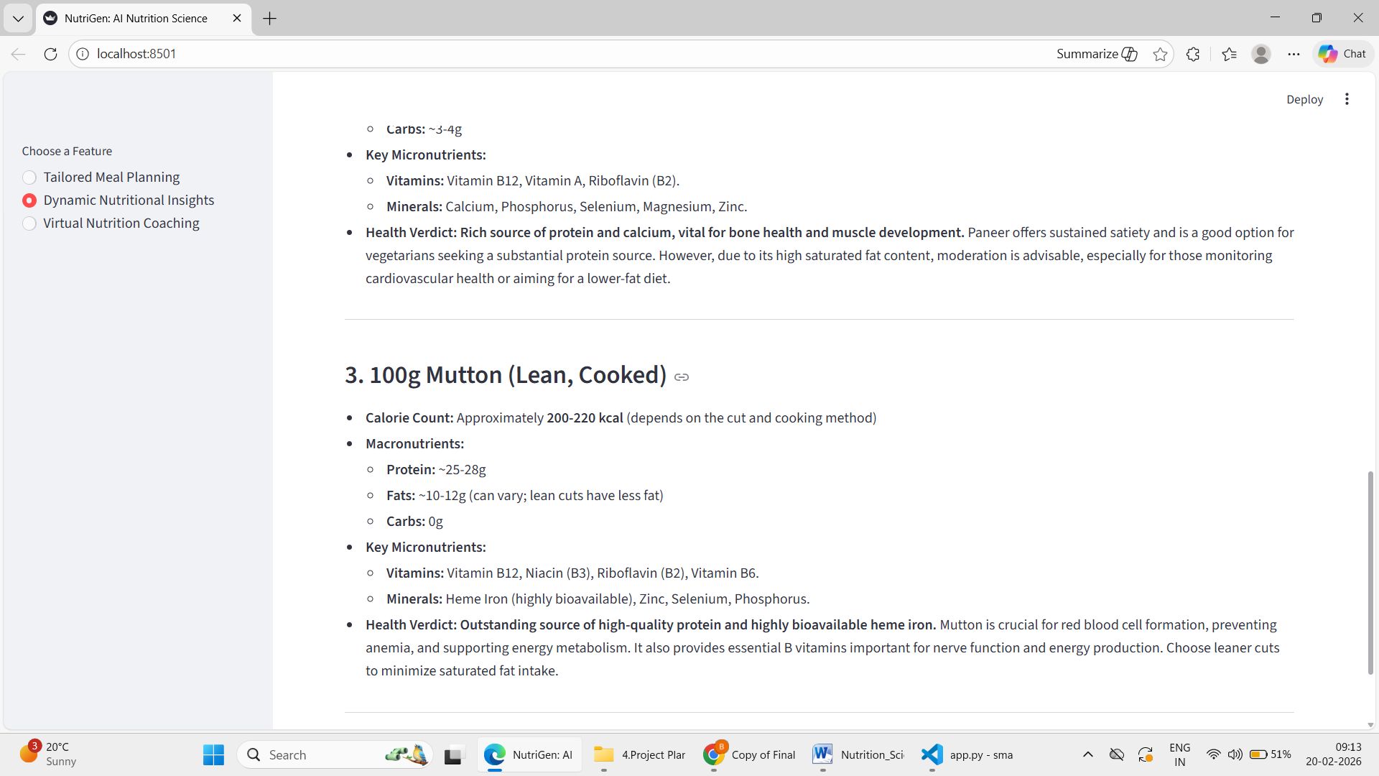

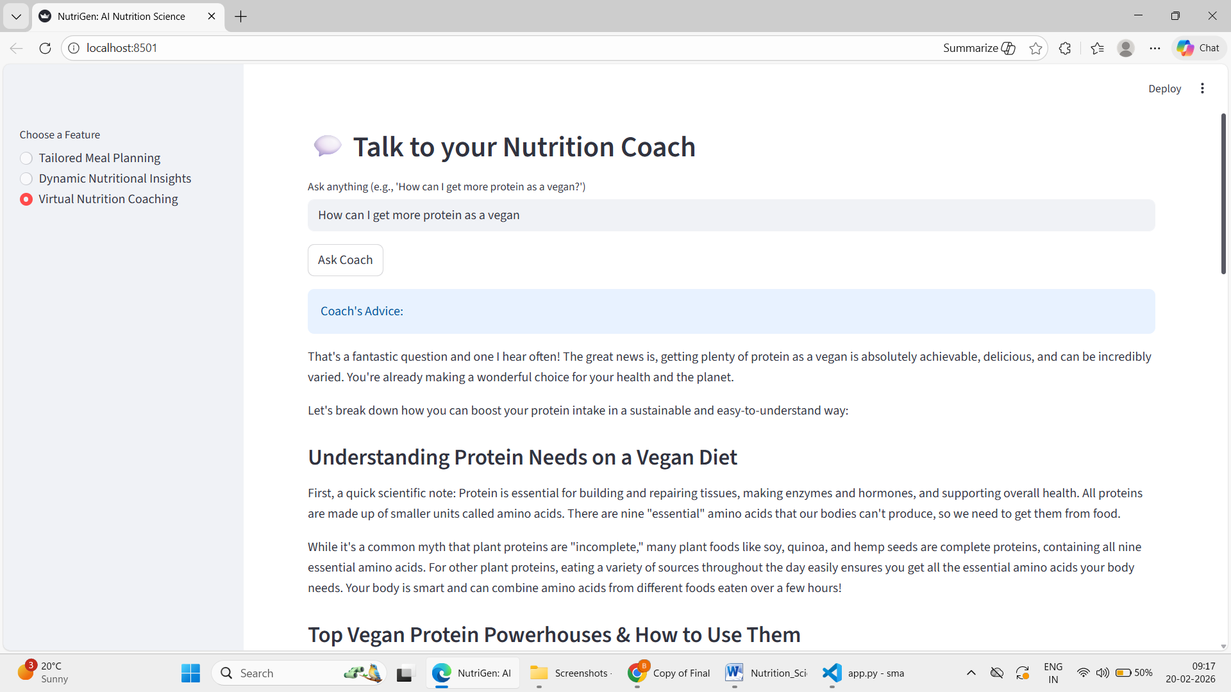

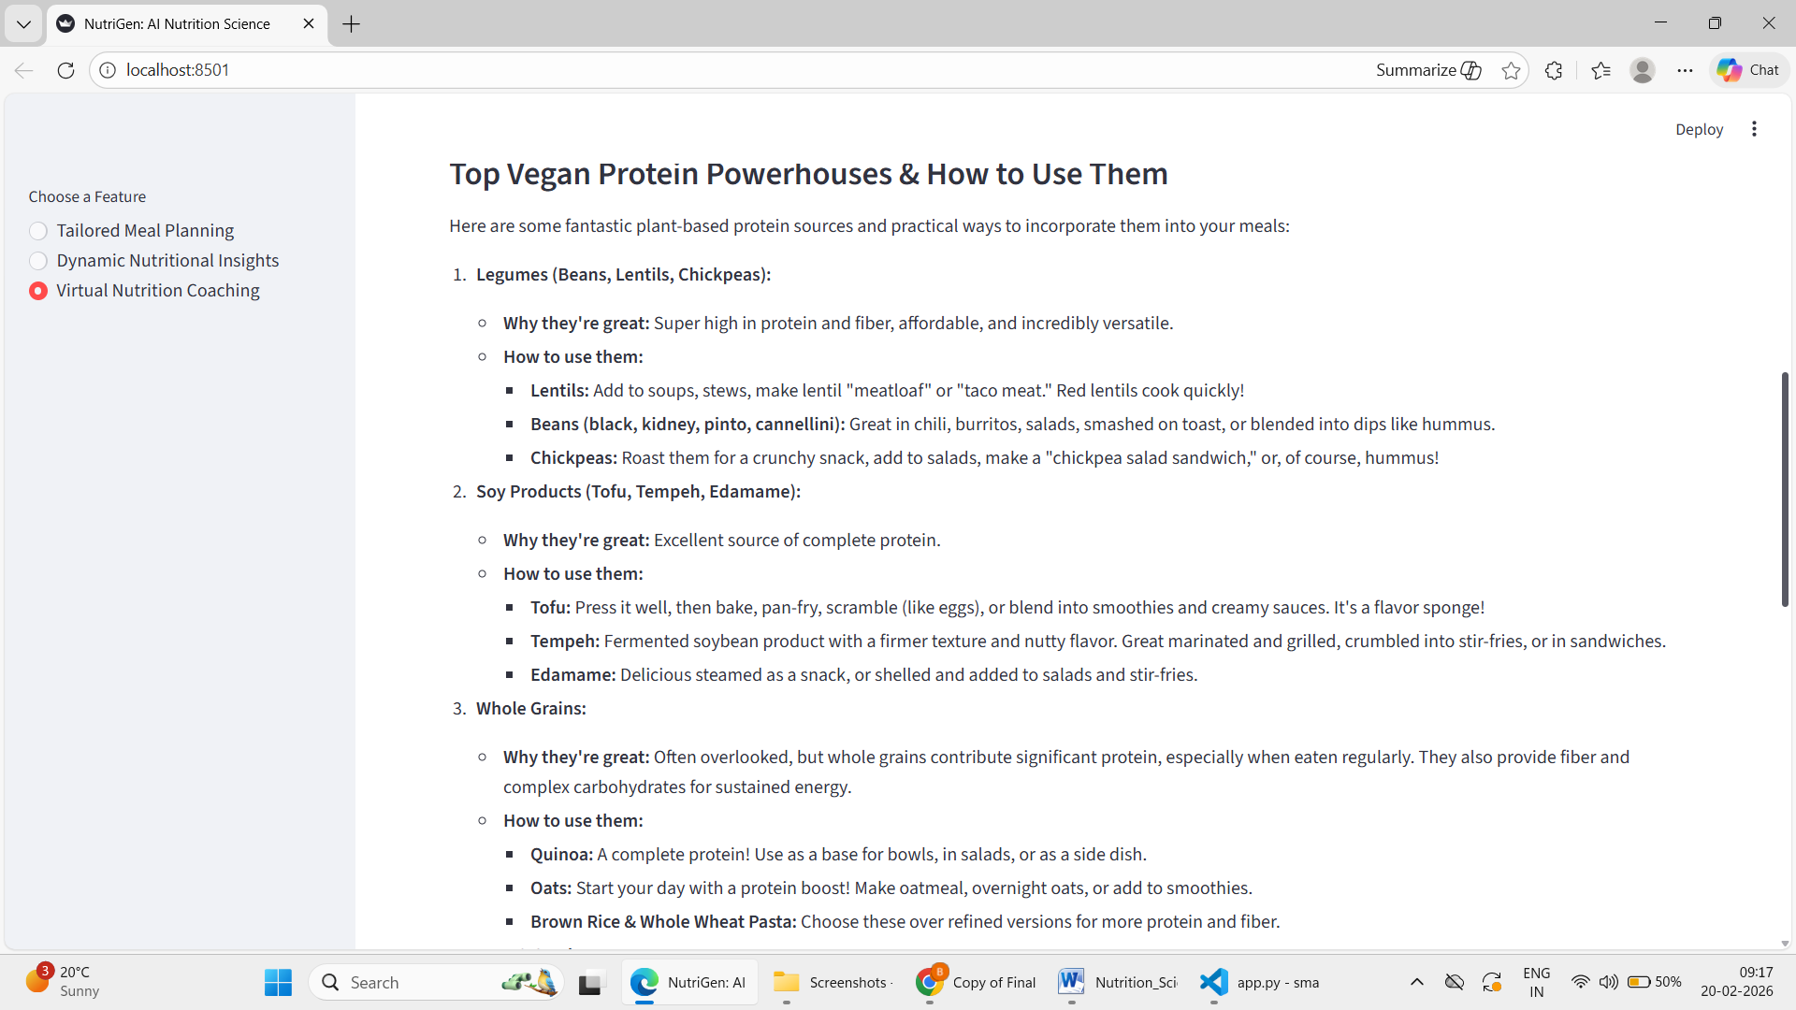

8. ADVANTAGES & DISADVANTAGES

8.1 Advantages
- · Provides real-time nutrition insights
- · Generates personalized meal plans
- · Offers AI-powered virtual nutrition coaching
- · User-friendly and interactive interface
- · No dataset required for training
- · Fast and efficient response generation
- · Supports both text and image input
- · Helps users make healthier lifestyle decisions

8.2 Disadvantages
- Requires continuous internet connection
- Depends on third-party AI API services
- Accuracy depends on clarity of user input
- Cannot replace professional medical consultation
- Limited offline functionality

9. CONCLUSION
The Advancing Nutrition Science through GeminiAI project successfully demonstrates the application of generative AI in the field of nutrition and healthcare. The system provides intelligent nutritional insights, personalized meal planning, and virtual coaching through an easy-to-use web interface.
By leveraging Gemini AI, the application helps users understand food composition, make informed dietary decisions, and adopt healthier lifestyle habits. The project highlights how AI can make personalized nutrition guidance accessible, affordable, and efficient for everyone.

10. FUTURE SCOPE
- Barcode-based food scanning system
- Mobile application development (Android/iOS)
- Multi-language support for wider accessibility
- Diet tracking and progress monitoring dashboard
- Integration with wearable fitness and health devices
- AI-based calorie tracking system
- Voice-based interaction with nutrition coach
- Personalized diet recommendations based on medical history

11. APPENDIX

Source Code
The complete source code for this project—including the Streamlit frontend, AI service orchestration, and environment configurations—is available for review in the submitted repository.

Dataset Link
This project primarily utilizes the pre-trained knowledge of the Gemini 2.5 Flash Lite model; however, any custom prompts or fine-tuning datasets used for testing are documented in the project documentation.

GitHub & Project Demo Link
- GitHub Repository: [Bavan-sai/Nutrigen-Advancing-Nutrition-Science-through-GeminiAI-]
- Live Project Demo: [Insert Your Streamlit Sharing or Cloud Run Link Here]

